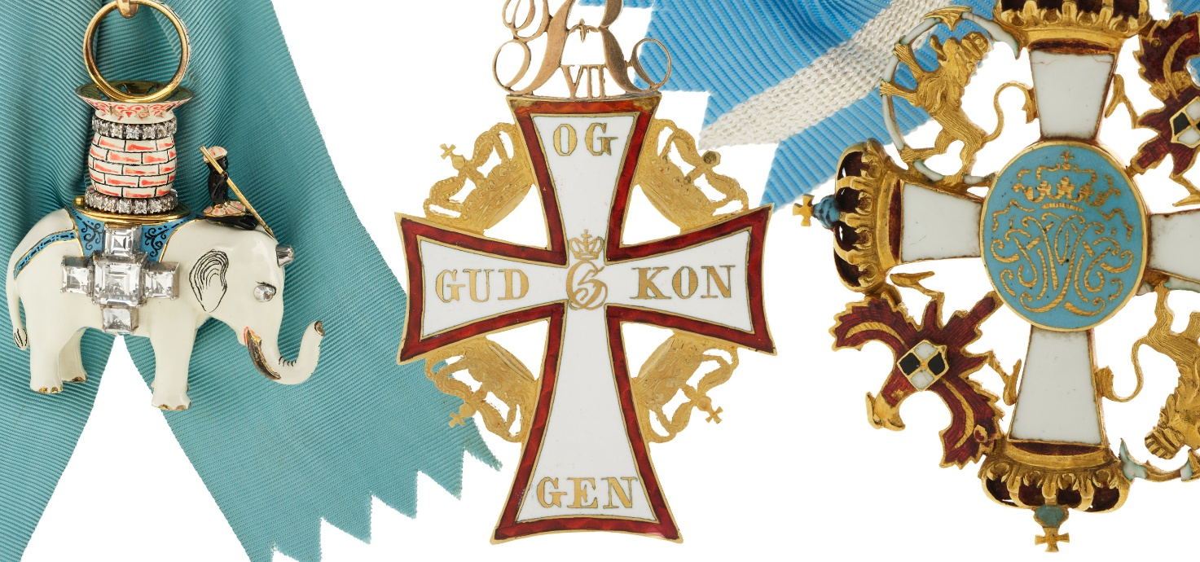
OPENING OF THE CHAMBER OF ORDERS AT FREDERIKSBORG
A newly established Chamber of Orders at Frederiksborg will introduce visitors to the Danish honours system and the Chapel of the Royal Danish Orders of Chivalry in Frederiksborg Castle Chapel. His Majesty King Frederik will participate in the official inauguration of the Chamber of Orders on 16 June. The Chamber of Orders opens to visitors on 17 June at 10.00 am and forms part of the museum’s permanent exhibition.
Thousands of coats of arms adorn the gallery of Frederiksborg Castle’s magnificent chapel, completed in 1617, as well as the grand staircases throughout the castle. Frederiksborg Castle Chapel houses the Chapel of the Royal Danish Orders of Chivalry, where Knights of the Order of the Elephant and Knights Grand Cross of the Order of the Dannebrog have, over the centuries, had their coats of arms displayed. His Majesty King Frederik X is Sovereign of the Danish Orders of Chivalry, and on 16 June, The King will inaugurate a newly established Chamber of Orders in which Frederiksborg presents the full collection of Royal Danish orders, decorations and medals.
The Chamber of Orders displays the Order of the Elephant, the Order of the Dannebrog, the Medal of Merit, the Medal of Recompense, the Ingenio et Arti Medal, and several rare orders that are no longer awarded. Visitors can also watch films featuring four Danes who have been honored with either a knighthood or a royal medal.
In 1671, King Christian V instituted the Order of the Dannebrog, with claimed roots in the chivalric traditions of the Middle Ages, as a complement to the ancient and prestigious Order of the Elephant. It was also Christian V who established the Chapel of the Orders in Frederiksborg Castle Chapel. Following the French model, King Frederik VI reformed the Order of the Dannebrog in 1808. No longer was noble birth or high rank in royal service required to receive the decoration. Ordinary citizens could now be recognised and honoured for their contributions to society – just as they can today.
PRESS & FACTS
Press
For visits to the Chamber of Orders or interview requests with Tore Leifer, Editor at Frederiksborg, please contact: Sara Juel Andersen, Head of Communications, sja@frederiksborg.dk
Members of the press are welcome to attend the inauguration of the Chamber of Orders on 16 June. Requests for accreditation should be sent to sja@frederiksborg.dk.
For further information, please visit frederiksborg.dk/presse.
About Frederiksborg Castle Chapel
Frederiksborg Castle Chapel was commissioned by King Christian IV and completed in 1617 as part of the magnificent castle he built on the site of his birthplace. During the King's lifetime, the chapel was opened to local residents after the parish church was destroyed by fire. Frederiksborg Castle Chapel continues to serve as the local parish church today.
During the period of absolute monarchy, Danish kings were anointed in the chapel. In 1694, King Christian V designated it as the chapel of the Danish Orders of Chivalry, a role it continues to fulfil to this day. The coats of arms of Knights of the Order of the Elephant and Knights Grand Cross of the Order of the Dannebrog are still displayed in the chapel.
From June 2026, visitors to Frederiksborg will be able to explore the Danish honours system in the newly established Chamber of Orders.
About the Royal Danish Orders of Chivalry
For further information, please visit the website of the Danish Royal House and the section on the Chapel of the Orders and Armorial Books.
Om Frederiksborg
At Frederiksborg, visitors come face to face with the people, defining events and historical periods that have shaped Denmark. Frederiksborg is Denmark’s Museum of National History and National Portrait Gallery. The collections of portraits and history paintings are complemented by royal porcelain, silver, clocks, decorative arts and furniture. Together with the architecture of Frederiksborg Castle, they offer a unique insight into Denmark’s cultural heritage.
The museum is housed within Frederiksborg Castle, whose magnificent state rooms and historic interiors provide an exceptional setting for experiencing Danish history. Frederiksborg Castle Chapel, built for Christian IV, later served as the anointing church of Denmark’s absolute monarchs and today functions as the parish church. It is also home to the Chapel of the Royal Danish Orders of Chivalry.
The museum’s founder, brewer J.C. Jacobsen, founder of Carlsberg, made a significant contribution to the reconstruction of Frederiksborg following the devastating fire of 1859. Since its establishment as a museum in 1878, Frederiksborg has been owned by the Carlsberg Foundation.

